FRONT COVER:

Terms and Conditions

LEGAL NOTICE

The Publisher has strived to be as accurate and complete as possible in the creation of this report, notwithstanding the fact that he does not warrant or represent at any time that the contents within are accurate due to the rapidly changing nature of the Internet.

While all attempts have been made to verify information provided in this publication, the Publisher assumes no responsibility for errors, omissions, or contrary interpretation of the subject matter herein. Any perceived slights of specific persons, peoples, or organizations are unintentional.

In practical advice books, like anything else in life, there are no guarantees of income made. Readers are cautioned to reply on their own judgment about their individual circumstances to act accordingly.

This book is not intended for use as a source of legal, business, accounting or financial advice. All readers are advised to seek services of competent professionals in legal, business, accounting and finance fields.

You are encouraged to print this book for easy reading.

Table Of Contents
Foreword

Chapter 1:
Understanding Newsletters

Chapter 2:
Rationalities To Use E-mail Marketing To Make Revenue Online

Chapter 3:
Single or Double Opt In

Chapter 4:
Ways To Hike Up Opt In Rates

Chapter 5:
Best Email Marketing Tips

Wrapping Up

Foreword

Marketing thru e-mail is a crafty matter. It is mighty, but easily ill-used. It is simple, but really hard. May these tips, tricks and secrets make it simple and potent for you.

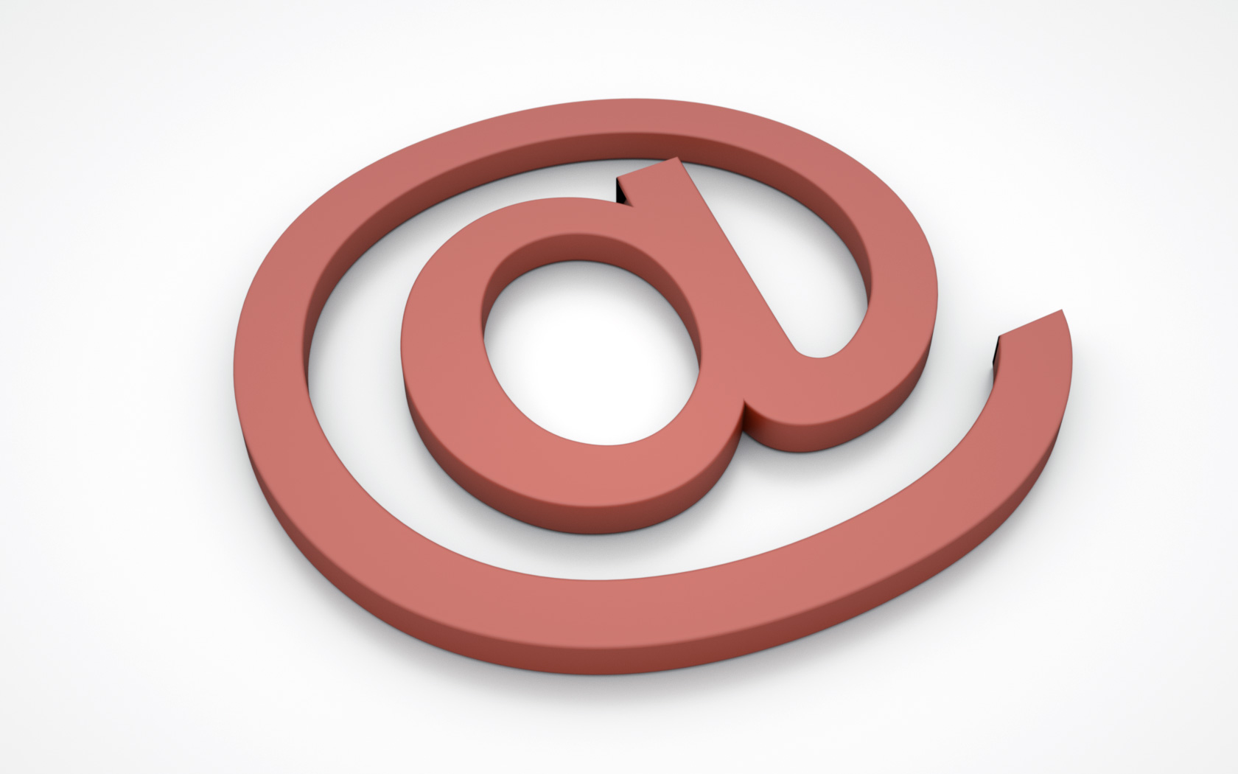

Email Marketing Tips For Effective Newsletters
How to use emails effectively and encourage your subscribers and get maximum results.

Chapter 1:
Understanding Newsletters

Synopsis

An e-mail newsletter is a newsletter that's delivered via e-mail that you are able to subscribe or opt-in to it.

E-mail delivery frequencies range from multiple times per day (almost never advocated) to daily to multiple times per week to weekly to bi-weekly, monthly, quarter or any periodic delivery schedule.

A few of the best newsletters are delivered daily, weekly, bi-weekly or month. Any delivery frequency longer than monthly isn't recommended.

What It Is

A crucial component to a 'newsletter is the permission you give the newsletter publisher. Double or confirm-opt-in is the best technique of subscription and this implies that you not only requested to get the e-mail newsletter, but you confirmed your request to get it by clicking on a confirmation link or replying to e-mail verification. Any mailing list that doesn't call for confirmation or a subscription process is spam (unsolicited commercial e-mail).

An newsletter commonly will come in a plain ASCII text format or via a rich HTML format or allow both formats via an auto e-mail client detection technique called MIME/Multipart. You ought to never send PDF's or any other large file to your e-mail list members unless they're expecting it and can handle it getting your files.

Why do individuals publish mailing lists? It's a vital business tool to create relationships within your niche, to keep in contact with your customers or members, construct your credibility or perceived expertise in the market and drive leads, sales and/or revenue by selling products/services or advertising beside quality original content.

Among the best things you're able to do to put your e-mail marketing campaigns to work is to compose valuable content. Consider writing your content so that it does the ‘work’ for somebody else. In any event, that work ought to relate heavily to a product or service that you supply, and act as a subtle resource for someone who might be debating on whether they should be your purchaser.

For instance, if you are a seller of particular memorabilia, write a newsletter about what qualities one ought to look for in a company selling memorabilia.

A lot of individuals might be concerned that they may be getting ripped-off by somebody selling fake memorabilia, so make them comfortable purchasing from you by highlighting what makes you legitimate… in a neutral way. Speak about certifications and associations that the true sellers have and belong to.

Discuss the nitty-gritty details of how crucial a high-res photograph is in confirming the validity of an item. Supply valuable resources that back your claim, and make your newsletter reach out to provide them advice.

By utilizing this sort of technique, you are able to easily highlight those strengths that your company has while providing a really enlightening newsletter for your subscribers. This produces a valuable resource that they would want to pass on to their acquaintances and co-workers all the while having your brand attached.

Although newsletters may be a excellent way to feature a new product or service that you provide, you have to think about what makes it worth reading, and more significantly, how can it make you stick out as an expert!

Chapter 2:
Rationalities To Use E-mail Marketing To Make Revenue Online

Synopsis

After dropping a couple of years fumbling around making revenue online here and there, I have determined the heartiest, uniform way of doing it is to make e-mail marketing fundamental to your sales scheme.
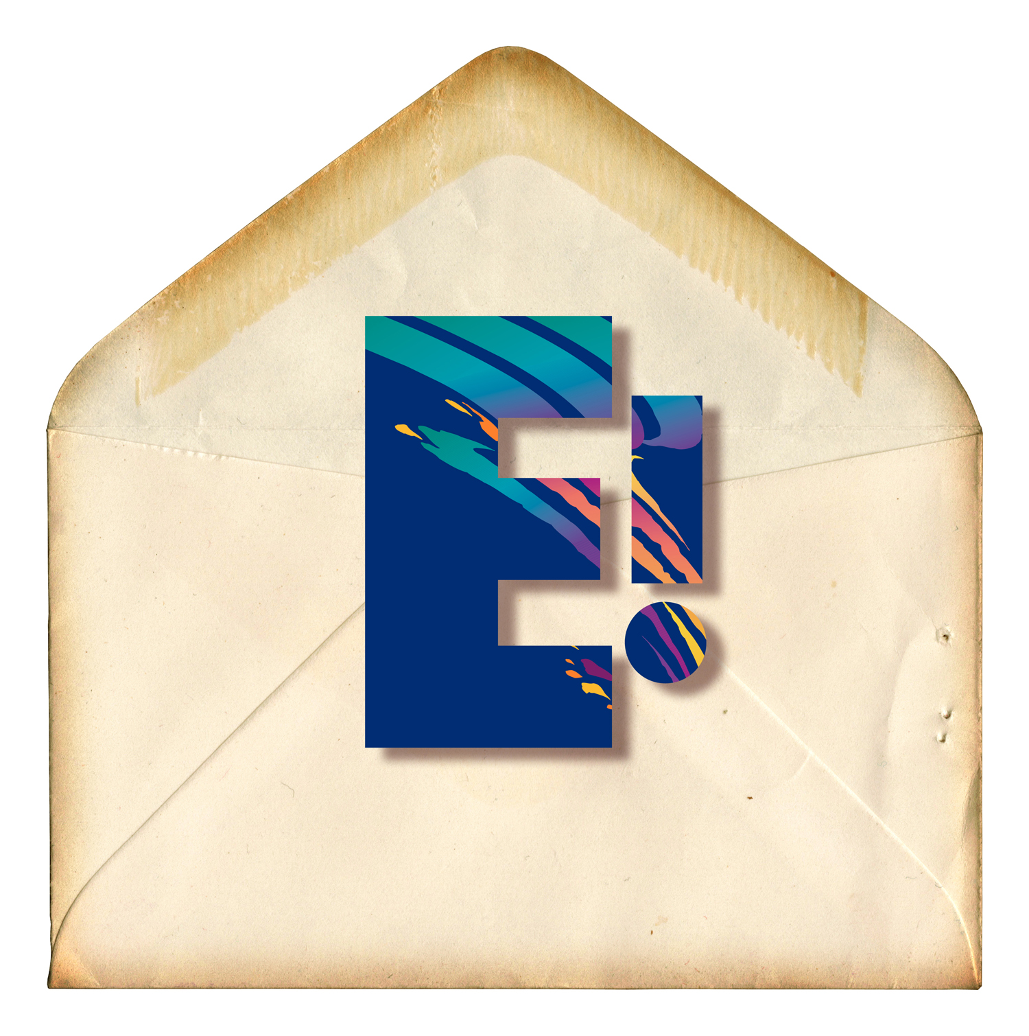

Why You Should

Previously in my career, I naively sent traffic straight to merchant web sites utilizing affiliate links. Some time later, I produced landing pages so visitors would “see” something new before making it to the merchant web site, while I neglected to utilize an opt in form.

Half-baked, yep... I was a newcomer. I rapidly discovered centering on driving traffic for one-time sales was only profiting the merchant, not me.

That's when I recognized the importance of follow through. Although my old landing pages were filled up with targeted material and personalized data, sales become more consistent till adding an autoresponder opt in form… granting me the lucrative chance to follow through with visitors.

This leads to the number 1 reason to utilize e-mail marketing to make revenue on the net...

Following through provides you the chance to expose your product or offer to visitors beyond their initial visit. It likewise provides you the opportunity to present your offer in more detail and answer general questions (FAQs) before they're even inquired.

Supplying answers in your follow through e-mails before they're asked (reading the subscriber's mind) may slide sales right to you.

What's excellent is when visitors opt into your form to get additional info, they’re expressing an interest to learn more & allowing you permission to contact them once again. It puts you in an great selling position. You’re now presented another prime chance to "catch the sale".

How great is that? Right! Simply remember...

E-mail Marketing = More Exposure = More chances To follow through

With prime Content = More revenue & Sales

Which feeds nicely into the 2nd rationality...

Hold on! Before you progress, print this. I guarantee you that you’ll get much more benefit from studying the data, instead of merely browsing through it on your computer. Before you even start reading… print out on paper. Get an ink pen. Circle or emphasize items of importance to you.
Doodle ideas and notes in the margins. Write up action steps.

Rationality No. 2 - one e-mail may equal mass gross sales. Once you’ve affected a trustworthy relationship with subscribers by sharing select free content and making recommendations that actively helps them in some manner, you'll have cultivated a list where one e-mail promotion may equal monumental sales. A privilege kin to having an ATM in your desktop.

There’s nothing more stimulating than making a excellent product recommendation to your e-mail list and having them react with enthusiastic sales that roll in almost instantly. Just be careful to never take your list for granted; they're real-live individuals. Treat them with honor, not cash machines.

Rationality No. 3 - Automation
The great thing about an automated marketing system that systematically pulls profits is that it's the closest thing to being able to "set & forget it".
E-mail marketing automation decidedly beats offline methods of follow through any day.

Would you rather spend a long time pitching prospects, answering questions, arming yourself with rebuttals, handling with rejection... all aimed to capture one sale -or- load an autoresponder with substantive material equally monetized with fruitful offers, set to act as your automated sales department?

I'd follow the latter, I'm sure you concur. That is, if you’re serious about having a successful net business that systematically makes you revenue & you comprehend the value of time/freedom.

Automation is key to successful development and profitability, in both the short and long-term. Having an automated e-mail scheme for interested leads to opt into, directly puts you in position to get automated sales. Automation lets you leverage sales in innumerable, creative ways.

Millionaires comprehend the might of automation & leverage: So if you ever doubt whether e-mail marketing is worth establishing as a central function of your marketing technique, remind yourself:
1) Multiple follow through chances to get sales,
2) One e-mail may = large-scale sales,
3) Leveraged automation.

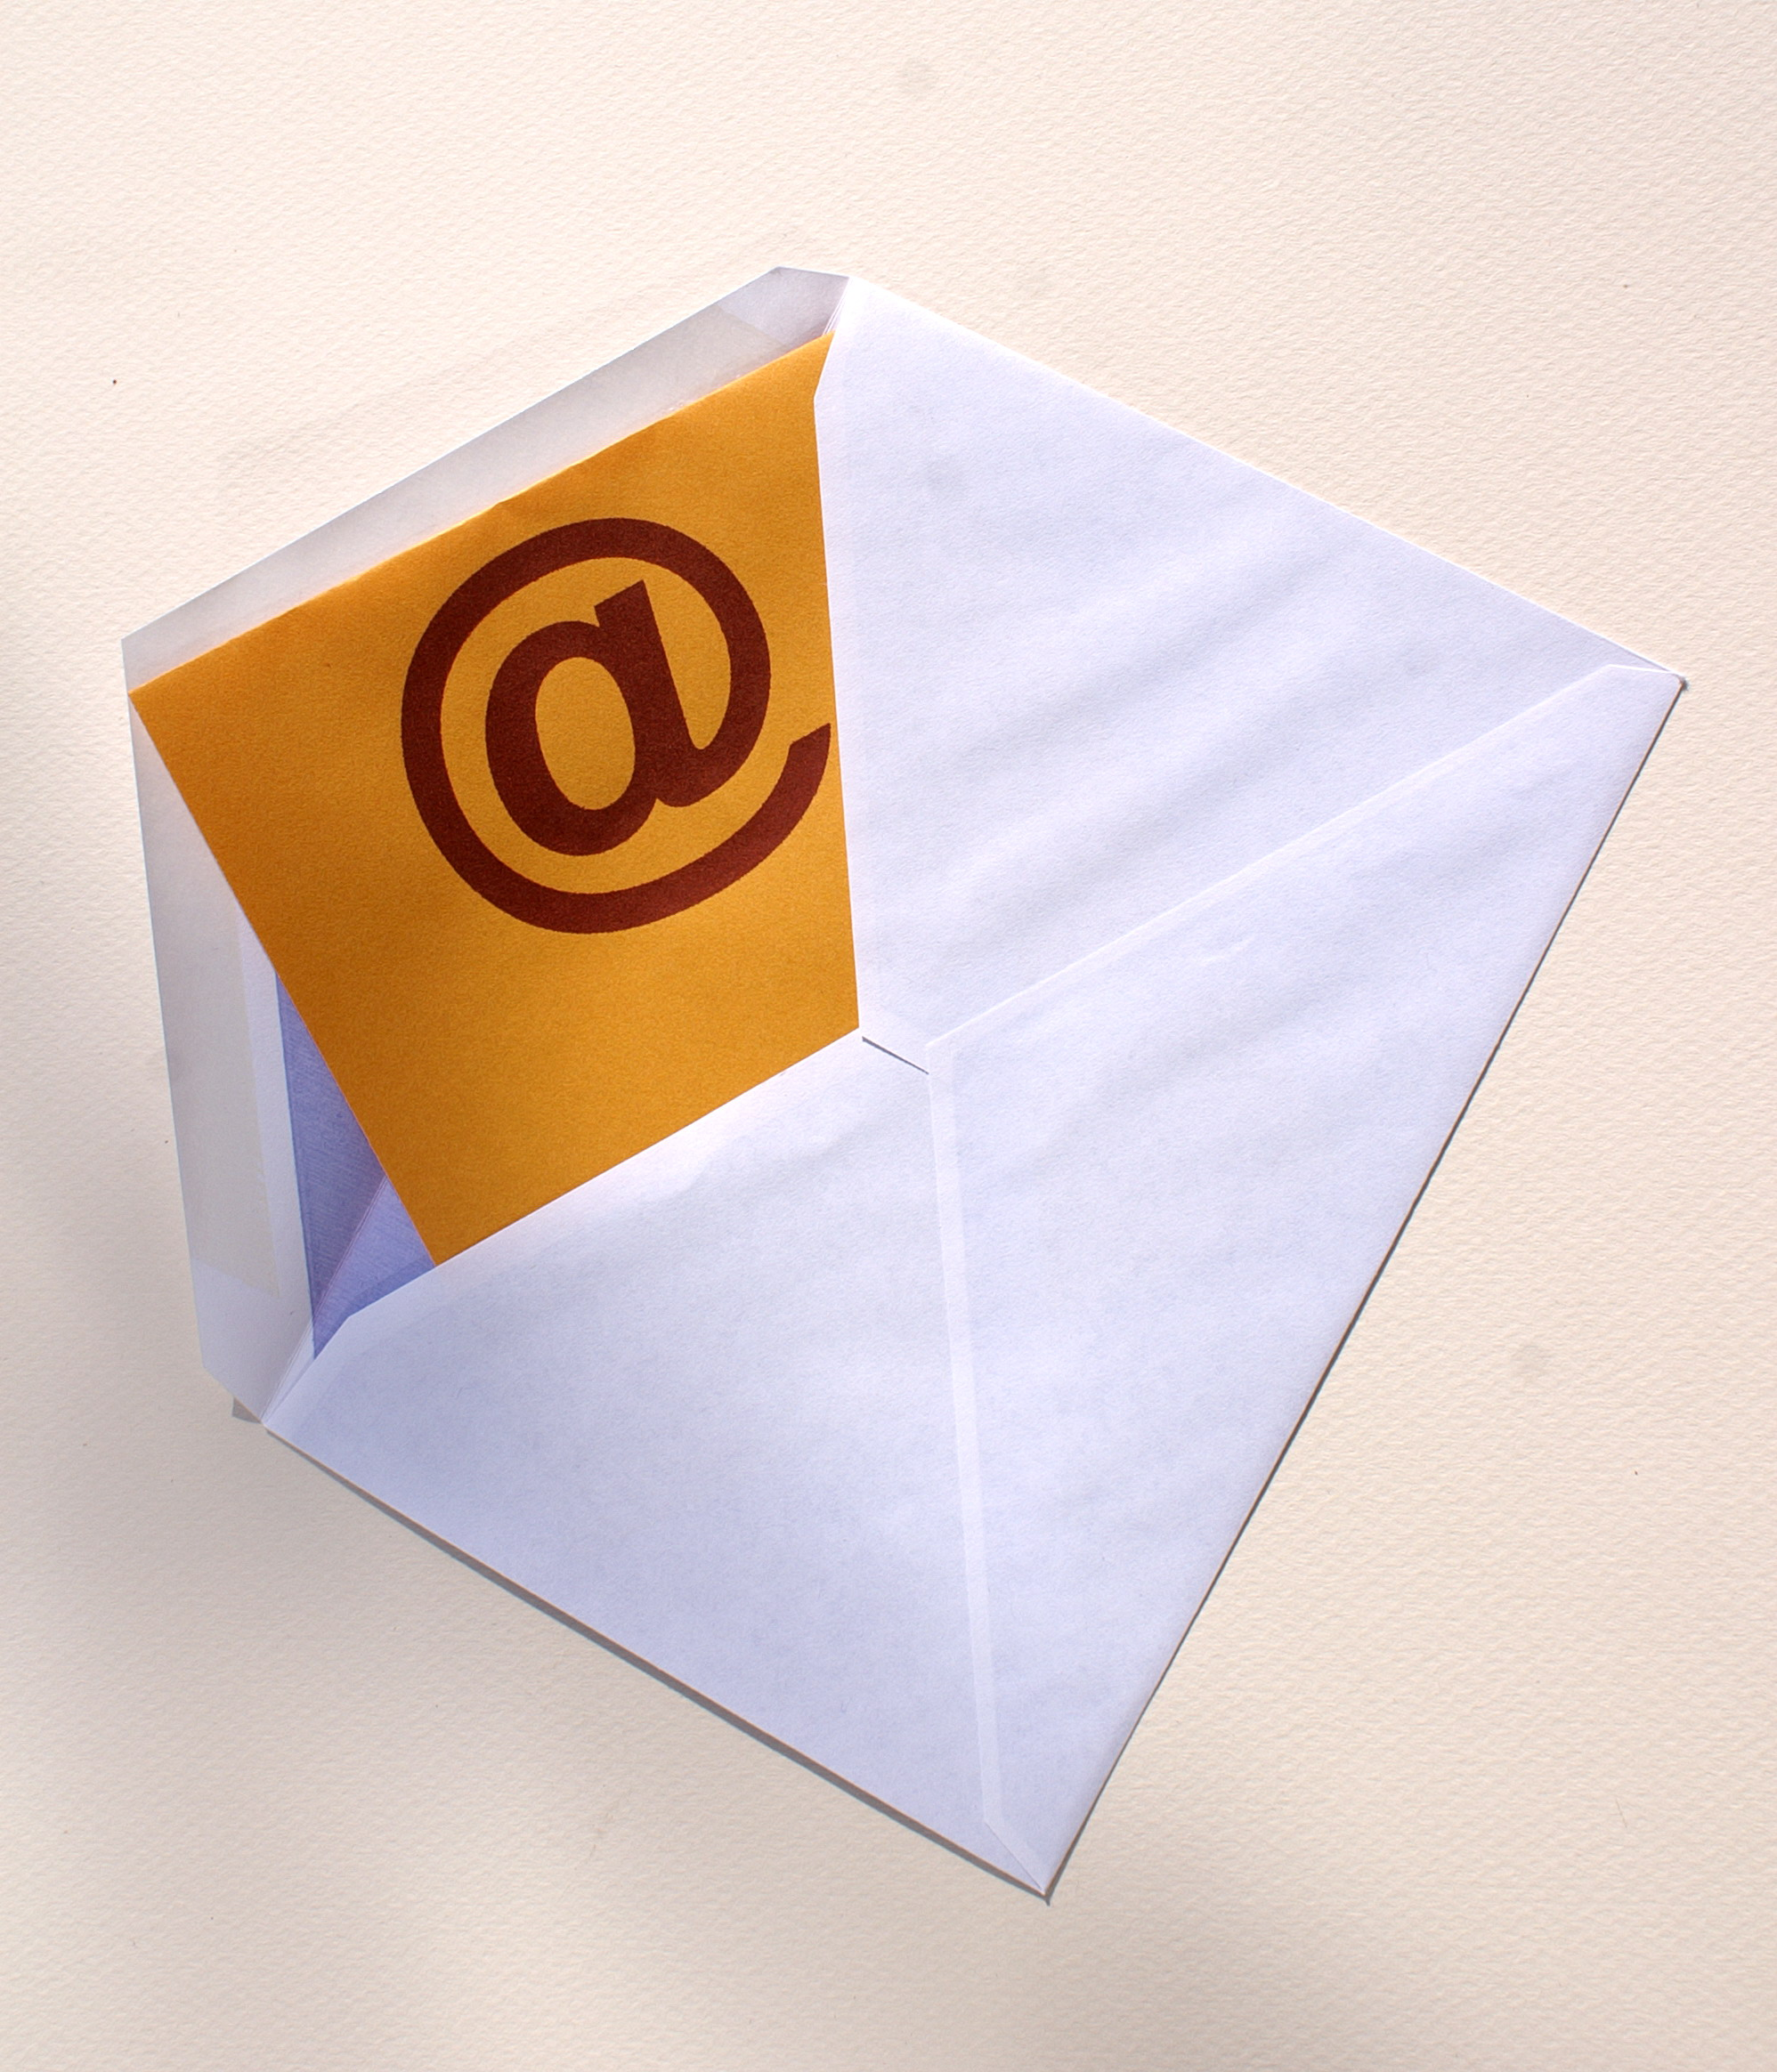

Chapter 3:
Single or Double Opt In

Synopsis

As an marketer, hopefully you comprehend the value of utilizing an autoresponder to construct a list. You'll inevitably face the question
of whether to utilization the “single or double opt in” option. It’s a common question in e-mail marketing, likewise a really crucial one in my opinion.

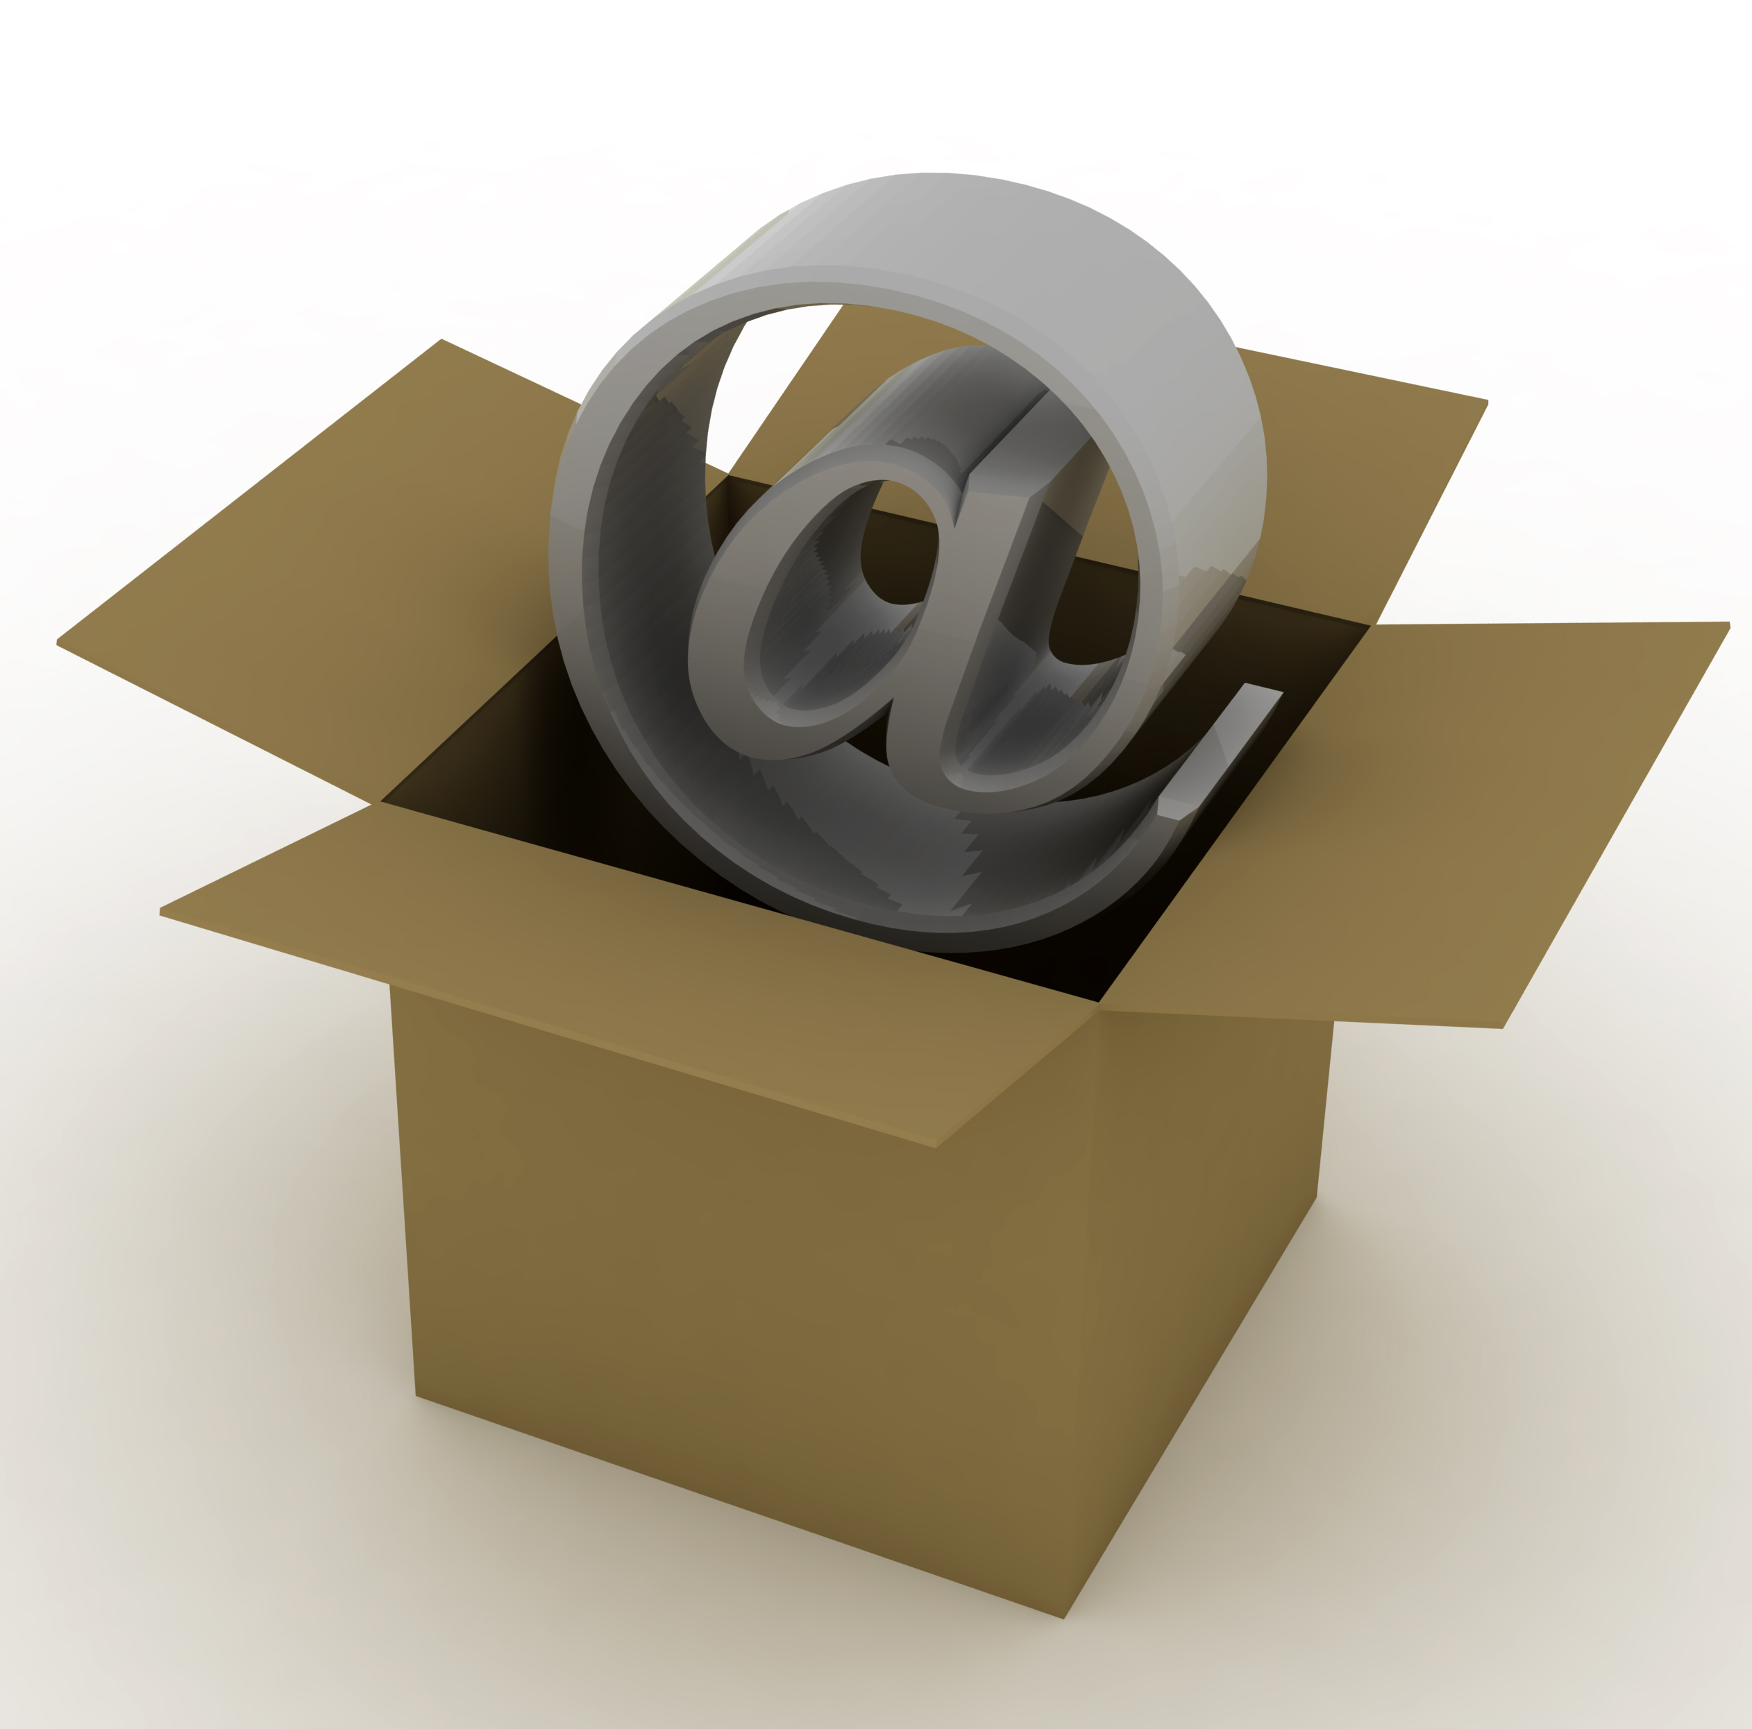

Which One

Several believe single opt in is better, in that they opt not to send a visitor through too many channels in order to get information…trusting less channels, more sales.

This might be true, dependent on the offer and the list, however with single opt in normally comes more SPAM complaints for a assortment of reasons:

· Don't care for the offer...
· Mad because you're promoting something for cash, even if you’re likewise supplying free helpful data...
· Sending out a follow-up e-mail 2 days or 2 weeks later

It may be anything. The thing is when these complaints mount, you have no recourse to prove these were legitimate requests made through your opt in form. And if they don't holler spam, single opt in tends to clog your list with non-responsive, tire-kickers. Common reason being, opt in's are not made to affirm "Yes, I require this info."

Once opt in's take the time to go into their inbox & click a "confirmation link", they're re-affirming, "Yes, I decidedly wish to get this info."
When you require a potential subscriber carry out the motions of confirming, you’re pulling them out of simply acting passively, out of instinct.
You're making them not only state, "yep." (passively, unconsciously) but "Yes, Yes!”. Just in case you haven't figured it out by now, I favor double opt in.

Mainly as I spend time and effort producing quality material for my subscribers and I wish those who request it to truly want it, pay attention when they get it and really value what I'm providing.

Reasons For Double Opt In

1 - You wish visitors who subscribe to pay attention to what you're providing - double opt in does just that. Sorry people but human nature doesn’t by nature (or on first impulse) value opportunities or info that's readily given to them. Pitiful but true. It's up to you make subscribers realize the info they're requesting as being useful and highly-important.

2 - you've confirmed data (proof) that somebody at that e-mail address utilized that name on that date at that time to request info be sent after visiting your site and they really clicked a link to confirm that the request was made.

Even though anybody may cry foul, or in that instance SPAM, you're safe, protected… as you now have valid proof on your side. This is how come explaining to visitors "How To Confirm" and "How To Unsubscribe" helps to diminish spam complaints.

You want it clear-cut that if they no longer wish to get info from you, then they may simply click unsubscribe in the email.

3 - You cultivate & sustain a clean, responsive e-mail list. E-mail marketing is the simplest way to make fast, consistent long-term revenue and how you do it's crucial in cultivating a highly-responsive list. A highly-responsive list comes as a consequence of earned trust and respect.

You likewise earn a particular amount of respect when somebody has to confirm their request, whether it's apparent or not. Because what you're stating is, "If you wish this material, you'll do what I'm asking you to do to acquire it."

True subscribers will abide by your request as the initial impression is...
1) You recognize what you're doing and
2) You're in it for the long run

You're likewise stating you respect them reciprocally. As a pro, you're taking extra measures to ensure their data is going to the right place. Individuals respect professionalism.

Individuals likewise value what is made to appear valuable. The value is evident once they get the info and it turns out to be truly excellent content that does something for them. If you’re provided content lives up to its sensed value, you've gained a subscriber's trust.

Maintain your newly built reputation and subscribers will trust, worth & respect what you have to state.

There are debates for single opt in option, however my experience has found them to be really weak and not worth their weight. I detest SPAM
as much as the next individual and as an e-mail marketer, I certainly don't want "spam charges" cluttering my business inbox. If a spam
Charge does arise; I may readily annihilate it with valid proof.

Separate "the genuine & serious" from "unconscious lookie-loos & freebie-seekers" as much as conceivable. Utilizing double opt in as part of your e-mail marketing technique lets you do just that. The gains are decidedly worth the effort.

This preview copy ends here and to get the full product, please go to (the website URL ) here to get the full product.

